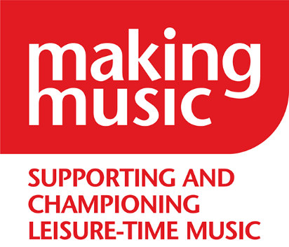Making Music

The National Federation of Music Societies

8 Holyrood Street

London SE1 2EL

Tel 020 7939 6030

info@makingmusic.org.uk

www.makingmusic.org.uk

The Duchess of Kent *Patron*

Debbie Wiseman OBE *President*

Dear Applicant,

**Membership & Services Administrator**

Thank you for your interest in this job with Making Music. We really hope you will apply and we are happy to make adjustments to our application process. Please email James ([office@makingmusic.org.uk](mailto:office@makingmusic.org.uk)) or phone 020 7939 6030 if we can help with different formats or in other ways which will let you demonstrate your capabilities.

Together with this letter, we hope you have downloaded the job description which tells you what we will expect you to do in this job and what we are looking for from you. Please contact James ([office@makingmusic.org.uk](mailto:office@makingmusic.org.uk)) or phone 020 7939 6030 if you would like us to email you the information instead.

If you would like to apply, please complete the [application form on our website](https://www.makingmusic.org.uk/application-form-membership-services-administrator). We ask you:

* for your contact details, so we can get in touch if we would like to meet you for an interview, but these will be separated from the rest of your application
* to complete three tasks/questions and it is your answers to these which the two shortlisters will use to create a longlist

If you are on the longlist, we will then ask you:

* to complete a second form with your education and employment or volunteer experience
* to answer one further question about whether you have experienced barriers to opportunities in the past due to a protected characteristic or your socio-economic background. If you have, and we have to decide between candidates of equal merit for interview, we will take positive action to include you on the final interview shortlist.

**Timeline**

* Please complete the application form no later than **9.00am on Monday 24th March 2025.**
* We will contact you by **5.00pm on Tuesday 25th March** if you are longlisted and we would like you to submit the second stage of information
* Deadline for submission of second form – **9.00am Monday 31st March.**
* We will notify you by **5.00pm on Tuesday 1 April** if we would like to interview you
* **Thursday 3 April** - Interviews will be in person in our office in London (near London Bridge).

We will pay your travel expenses to come to interview. If we ask you to interview, let us know if the time of your interview is important e.g. so you can travel in one day.

For more information about Making Music, see [www.makingmusic.org.uk](http://www.makingmusic.org.uk). If you would like more information about the job, please email [office@makingmusic.org.uk](mailto:office@makingmusic.org.uk) or call us on 020 7939 6030.

We look forward to receiving your application.

Yours faithfully,

Ben Saffell, Deputy Chief Executive, Membership & Business Development